EXAMPLE TESTS

GRADE 1: DICTATONS
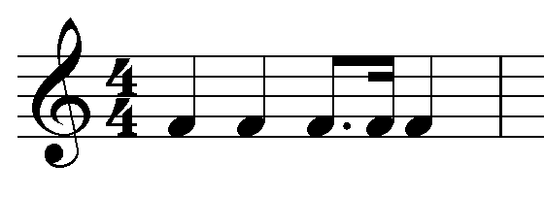
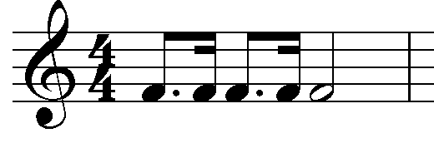
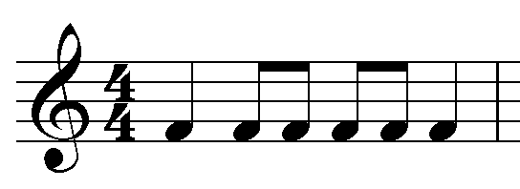
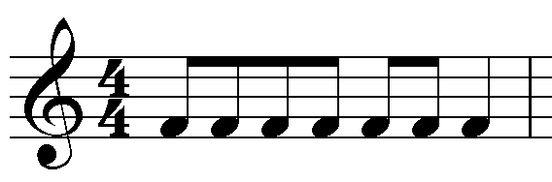

GRADE 2: DICTATIONS
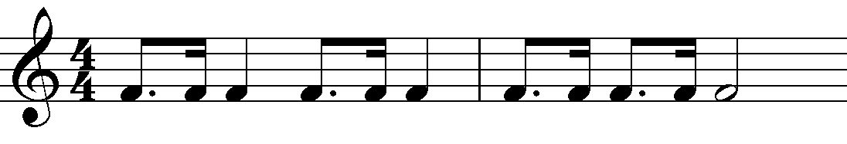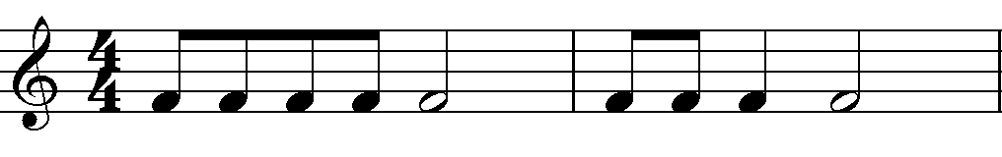

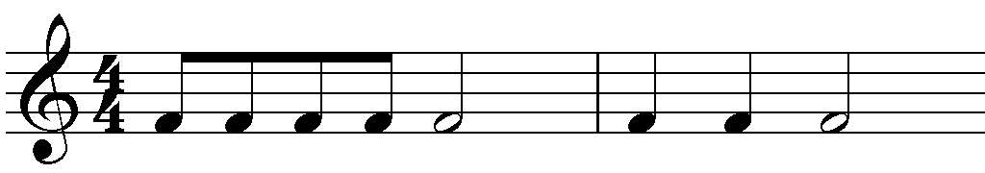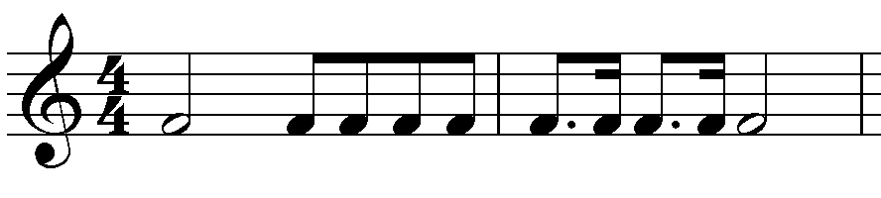

GRADE 2: STEPPING & BEATING

EXAMPLE TESTS

GRADE 2: ANACRUSIS/CRUSIS/METACRUSIS
